École Dansereau Meadows School
School Assurance Plan 2025-2026
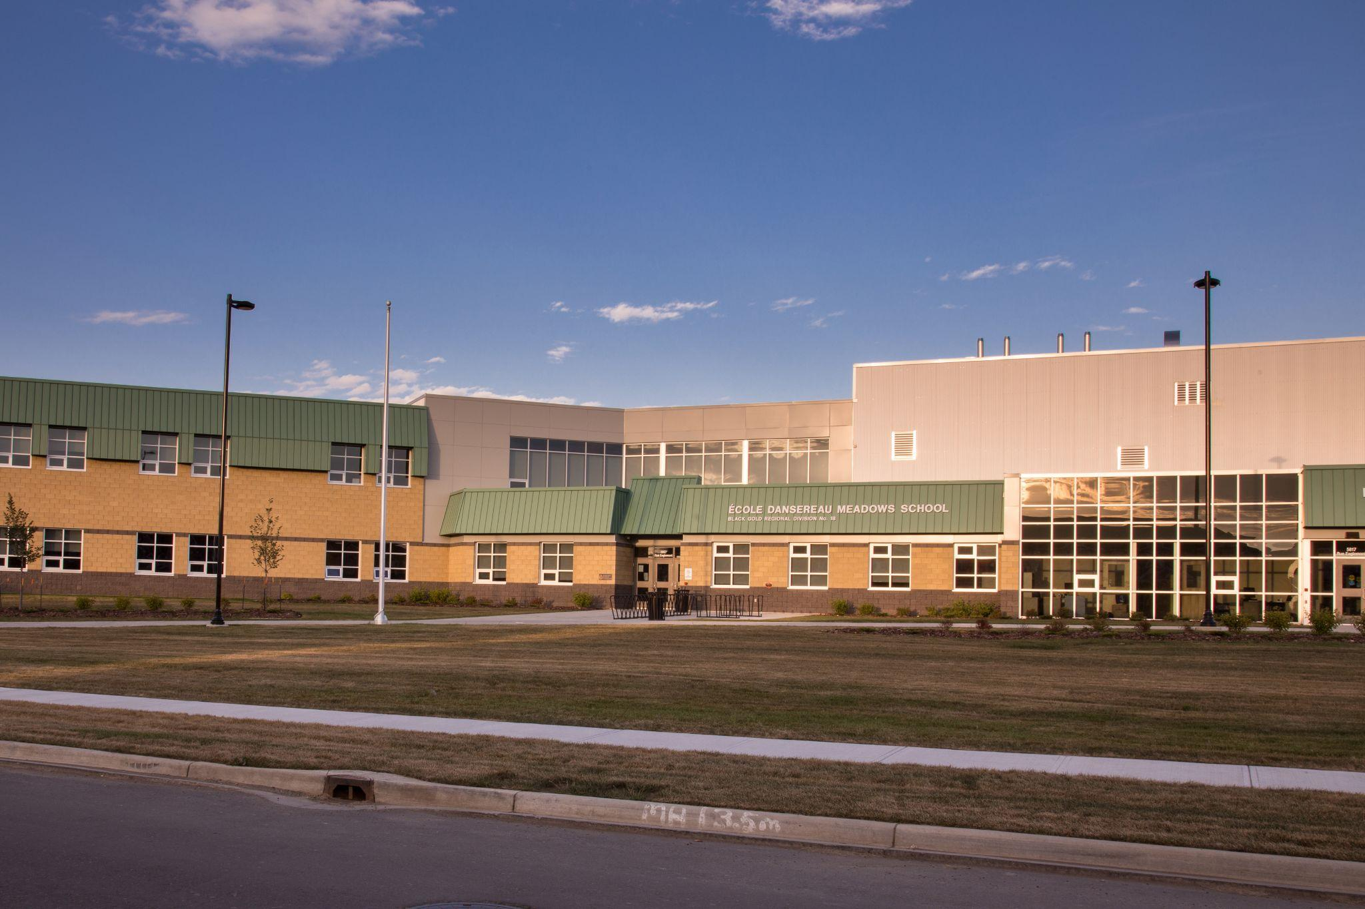

École Dansereau Meadows School Assurance Plan: 2025-2026

School Profile:
- École Dansereau Meadows School is located in Beaumont, Alberta. It is part of the Black Gold School Division. Our school offers Junior Kindergarten to Grade 9 in English (79%) and Kindergarten to Grade 6 in French Immersion (21%). We have 647 students (8% FNMI, 20% EAL 17% Special Needs) and 100% of our population is urban. Most students walk or are transported by parents to school; there is one district school bus that transports students to and from school. We have 34 certificated staff and 11 Education Assistants, 3 secretaries, 1 library technician, 1 Family School Liaison, and 4 custodians.
- NEW Vision – Inspiring minds, empowering individuals, and growing together in a caring, inclusive community rooted in curiosity, determination, and kindness.
- Core Values – Engagement, High Expectations, Personal Wellness, Collaboration, Leadership, Relationships
Celebrations:
- Student nutrition program provides breakfast for all students, and lunches or snacks to students in need
- Junior High extracurricular sports (running club, volleyball, curling club, basketball, badminton, flag football, track & field)
- Elementary extracurricular sports (running club, catch volleyball, basketball, flag football, floor hockey, Cross Country Running)
- Junior High Leadership (plan school spirit days, help out around the school with recycling, lost and found, small groups etc)
- CTF - Entrepreneurship Charity Market, Woods and Foods student products
- Dedicated School Council (some parents have been attending since we opened in 2014)
- French oral language incentive program (les Points coin-coin)

Academic Celebrations
- Teachers collaborate with grade level partners on best practices for literacy and numeracy.
- Education Assistants are provided with Professional Development to support students in literacy, numeracy and behaviour supports.
- There has been an increase in parent participation in the Assurance survey over the last 3 years ( In 2023 we had 34/132 = 26%. In 2024 we had 20/152 = 13%. In 2025 we had 40/128 = 31%)

School Events/Activities
- School Spirit days: Terry Fox, Orange Shirt Day, Ugly Christmas Sweater Day, Anything But a Backpack Day, Beach Day, Staff vs Students Games
- Pancake Breakfast, Concession Fundraisers (for athletics and Grade 9 Farewell)
- Spook N’ Spike Volleyball Tournament; Co-hosting Volleyball Jamboree with ÉCVS
- Christmas concert, Parent Guest readers, Grade 9 farewell, awards ceremony (honours, DUCK Awards), 6 Immersion farewell, Carnaval & Cabane á Sucre
- Guest Speakers/Presentations including Felice Gladue and Dallas Arcand
- Field trips (in-person and virtual)
- School Announcements over the PA System (celebrate student/staff birthdays, the theme of the month, jokes, in English/French, videos, and athletics announcements)
- Principal’s Weekly Update - blog post sent home at the end of each week to parents and staff.
- Social media posts about things happening in the school (Facebook)
- Family engagement nights - Fall and Spring Family Dances
- Remembrance Day ceremony with Saint André
- Water Bucket Challenge and Food Bank Drive

Challenges:
- Continued increase in social, emotional and behavioral issues among students; some with extremely high needs (ISP, BSP, EAL, SEB)
- Our survey results show a decrease in some areas such as Citizenship, Student Learning Engagement and Education Quality.

School Council Message

The ÉDMS School Council is a group of teachers and parents who are focused on the continued growth of the school and its students. Monthly meetings are held in person, on Thursdays, at 6:30 pm, in the school’s flex-space. The Administration Team invites all parents and community members to attend the meetings, with notifications being sent out in Weekly Updates and Agenda inserts.

The School Council Members have provided feedback for the Division calendars and engaged with the School Board Trustees when they have attended the meetings. We appreciate the support and advocacy our Trustees provide in the Black Gold School Division. With the upcoming municipal elections, we look forward to partnering with the newly elected/re-elected BGSD Trustees.

As a School Council, we strive to encourage the students of ÉDMS to become leaders of tomorrow.One of the ways that we have developed engagement is through the ÉDMS School Council Book Club. We used the Alberta School Councils Engagement Grant to purchase copies of “The Anxious Generation”, by Jonathan Haidt. We invited parents and teachers alike to join in reading and discussing the book, so we could better understand the challenges that our students face in a fast-paced, yet sedentary, social media driven world. The School Council looks forward to the next book club meeting in the 2025-2026 school year.

The ÉDMS School Council aims to support the academic and mental well-being of the entire school community. We want ÉDMS to be seen as a safe space for all who attend and we support our teachers and educators in all that they do for us. On behalf of the Council, we thank all staff and parent volunteers that continue to make our school the warm, safe, and welcoming environment we know and love.

Warmest Regards,
Gemma Iwanciwski
School Council Chair School Assurance Plan Fall Update: September 25th, 2025

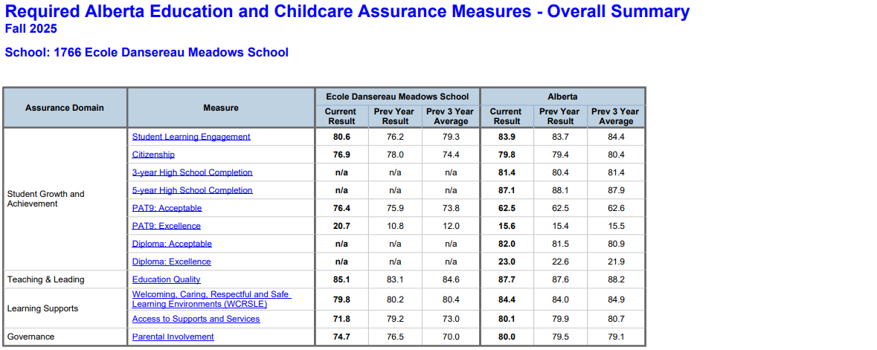

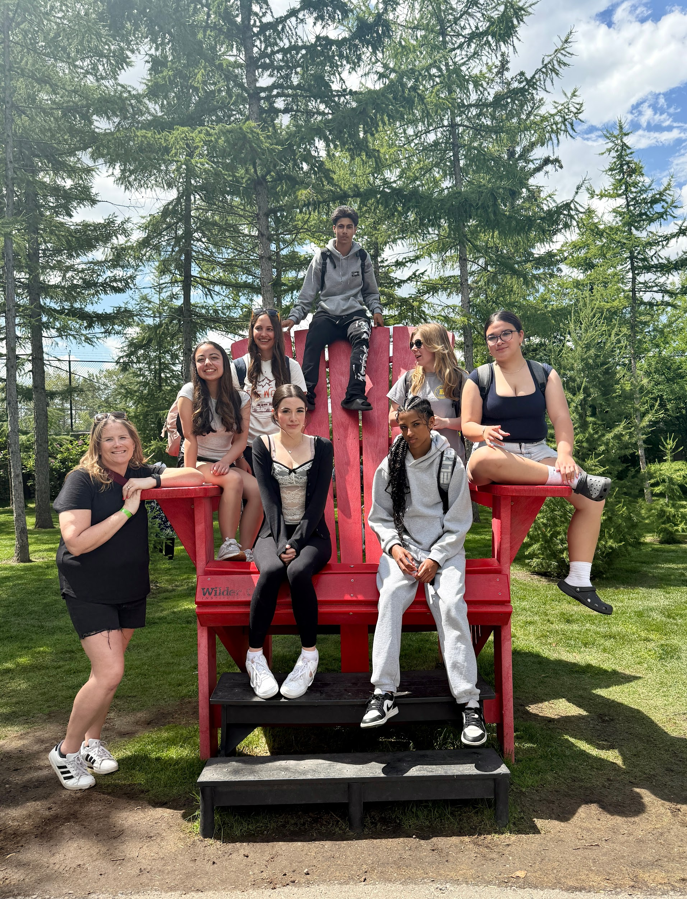
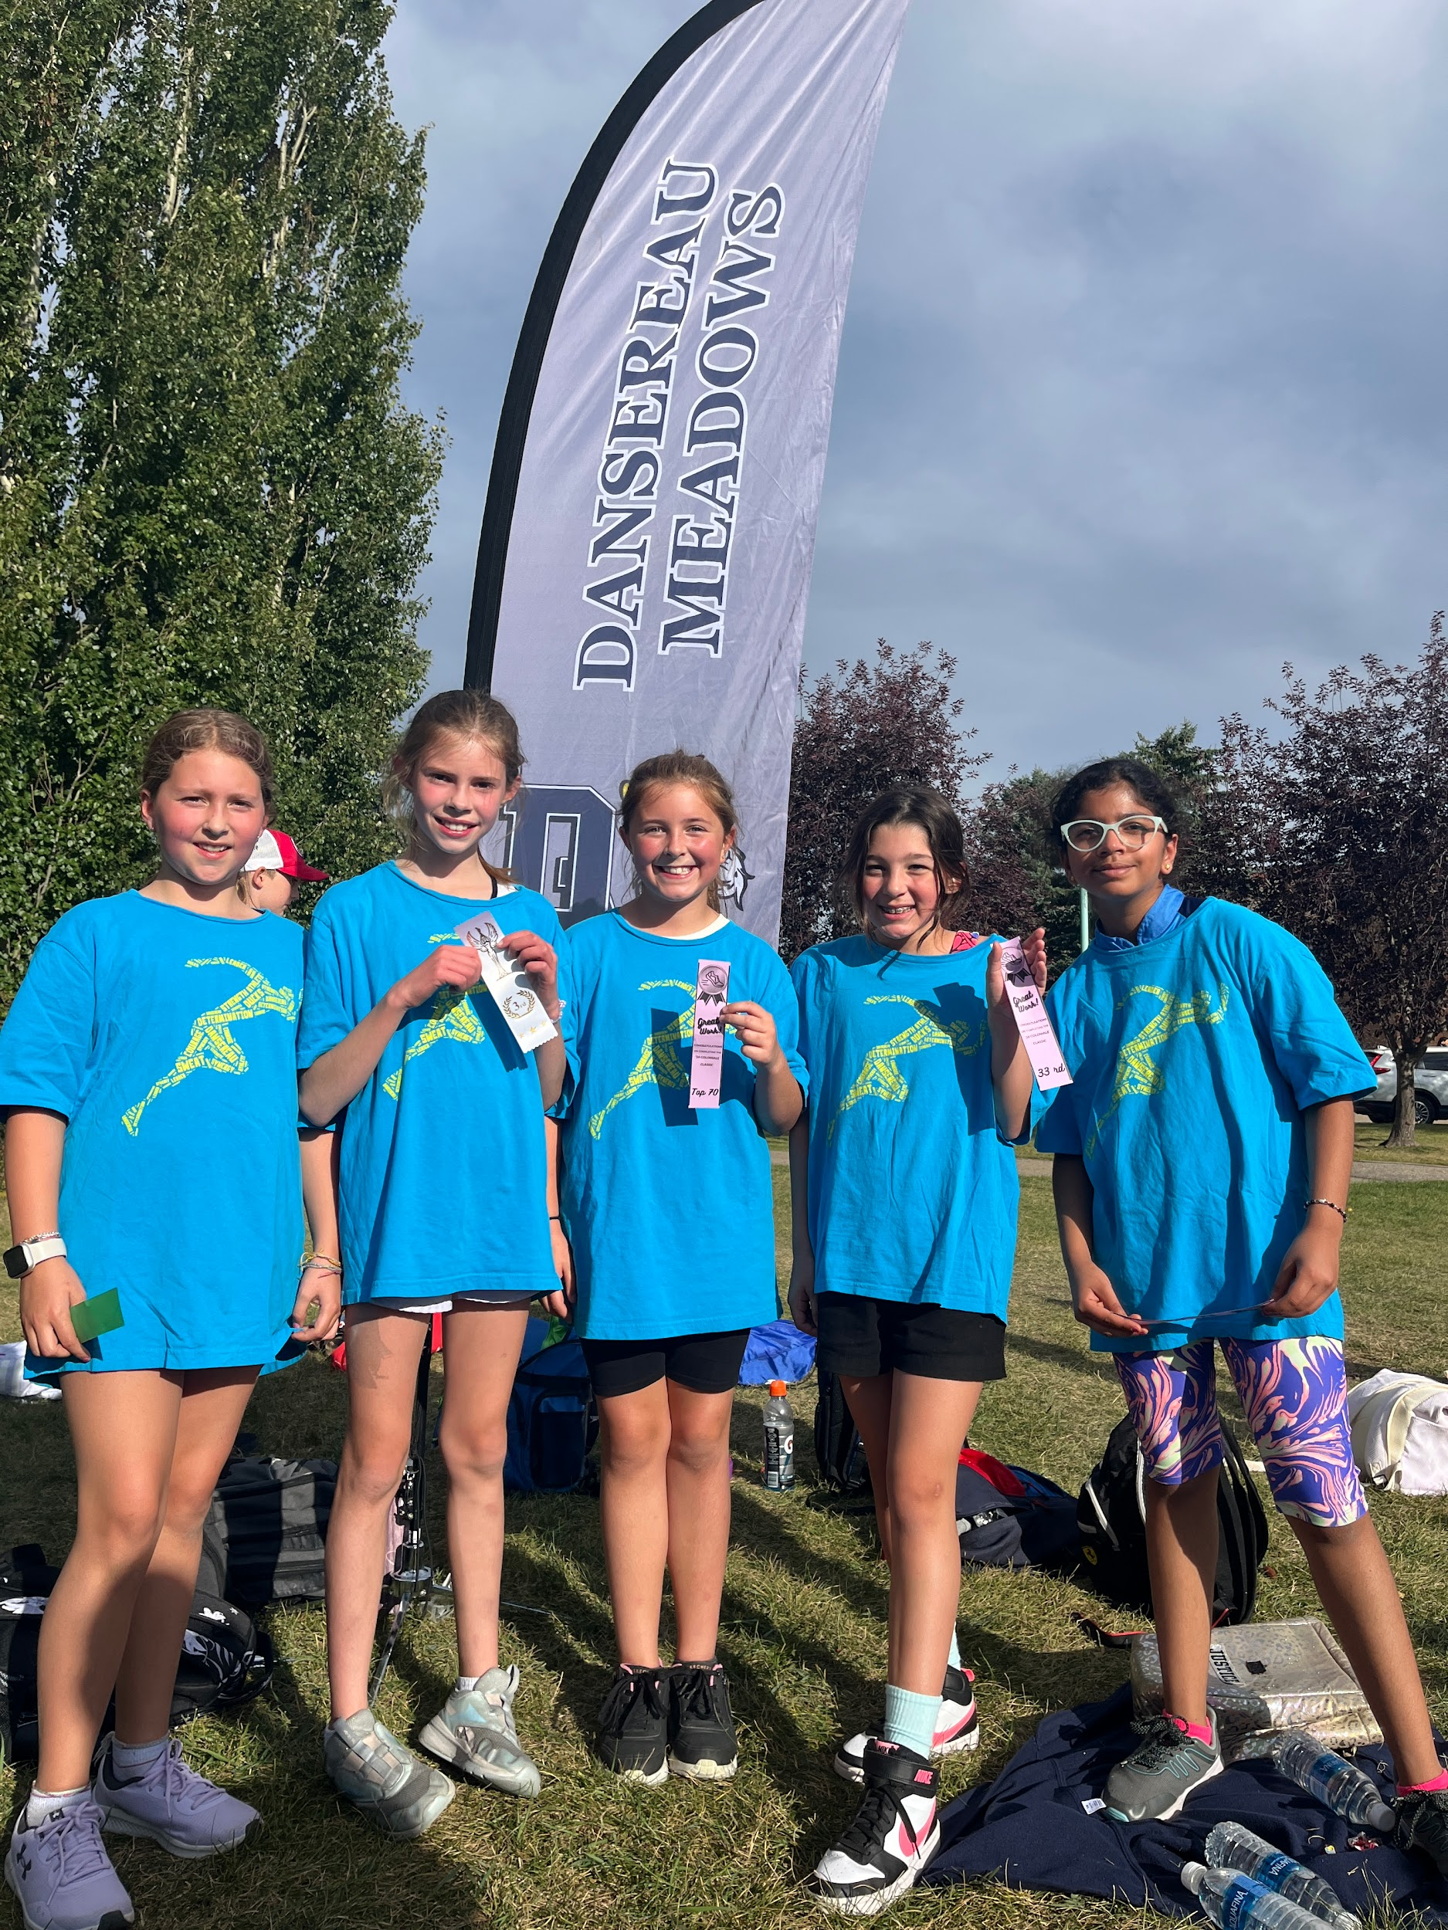
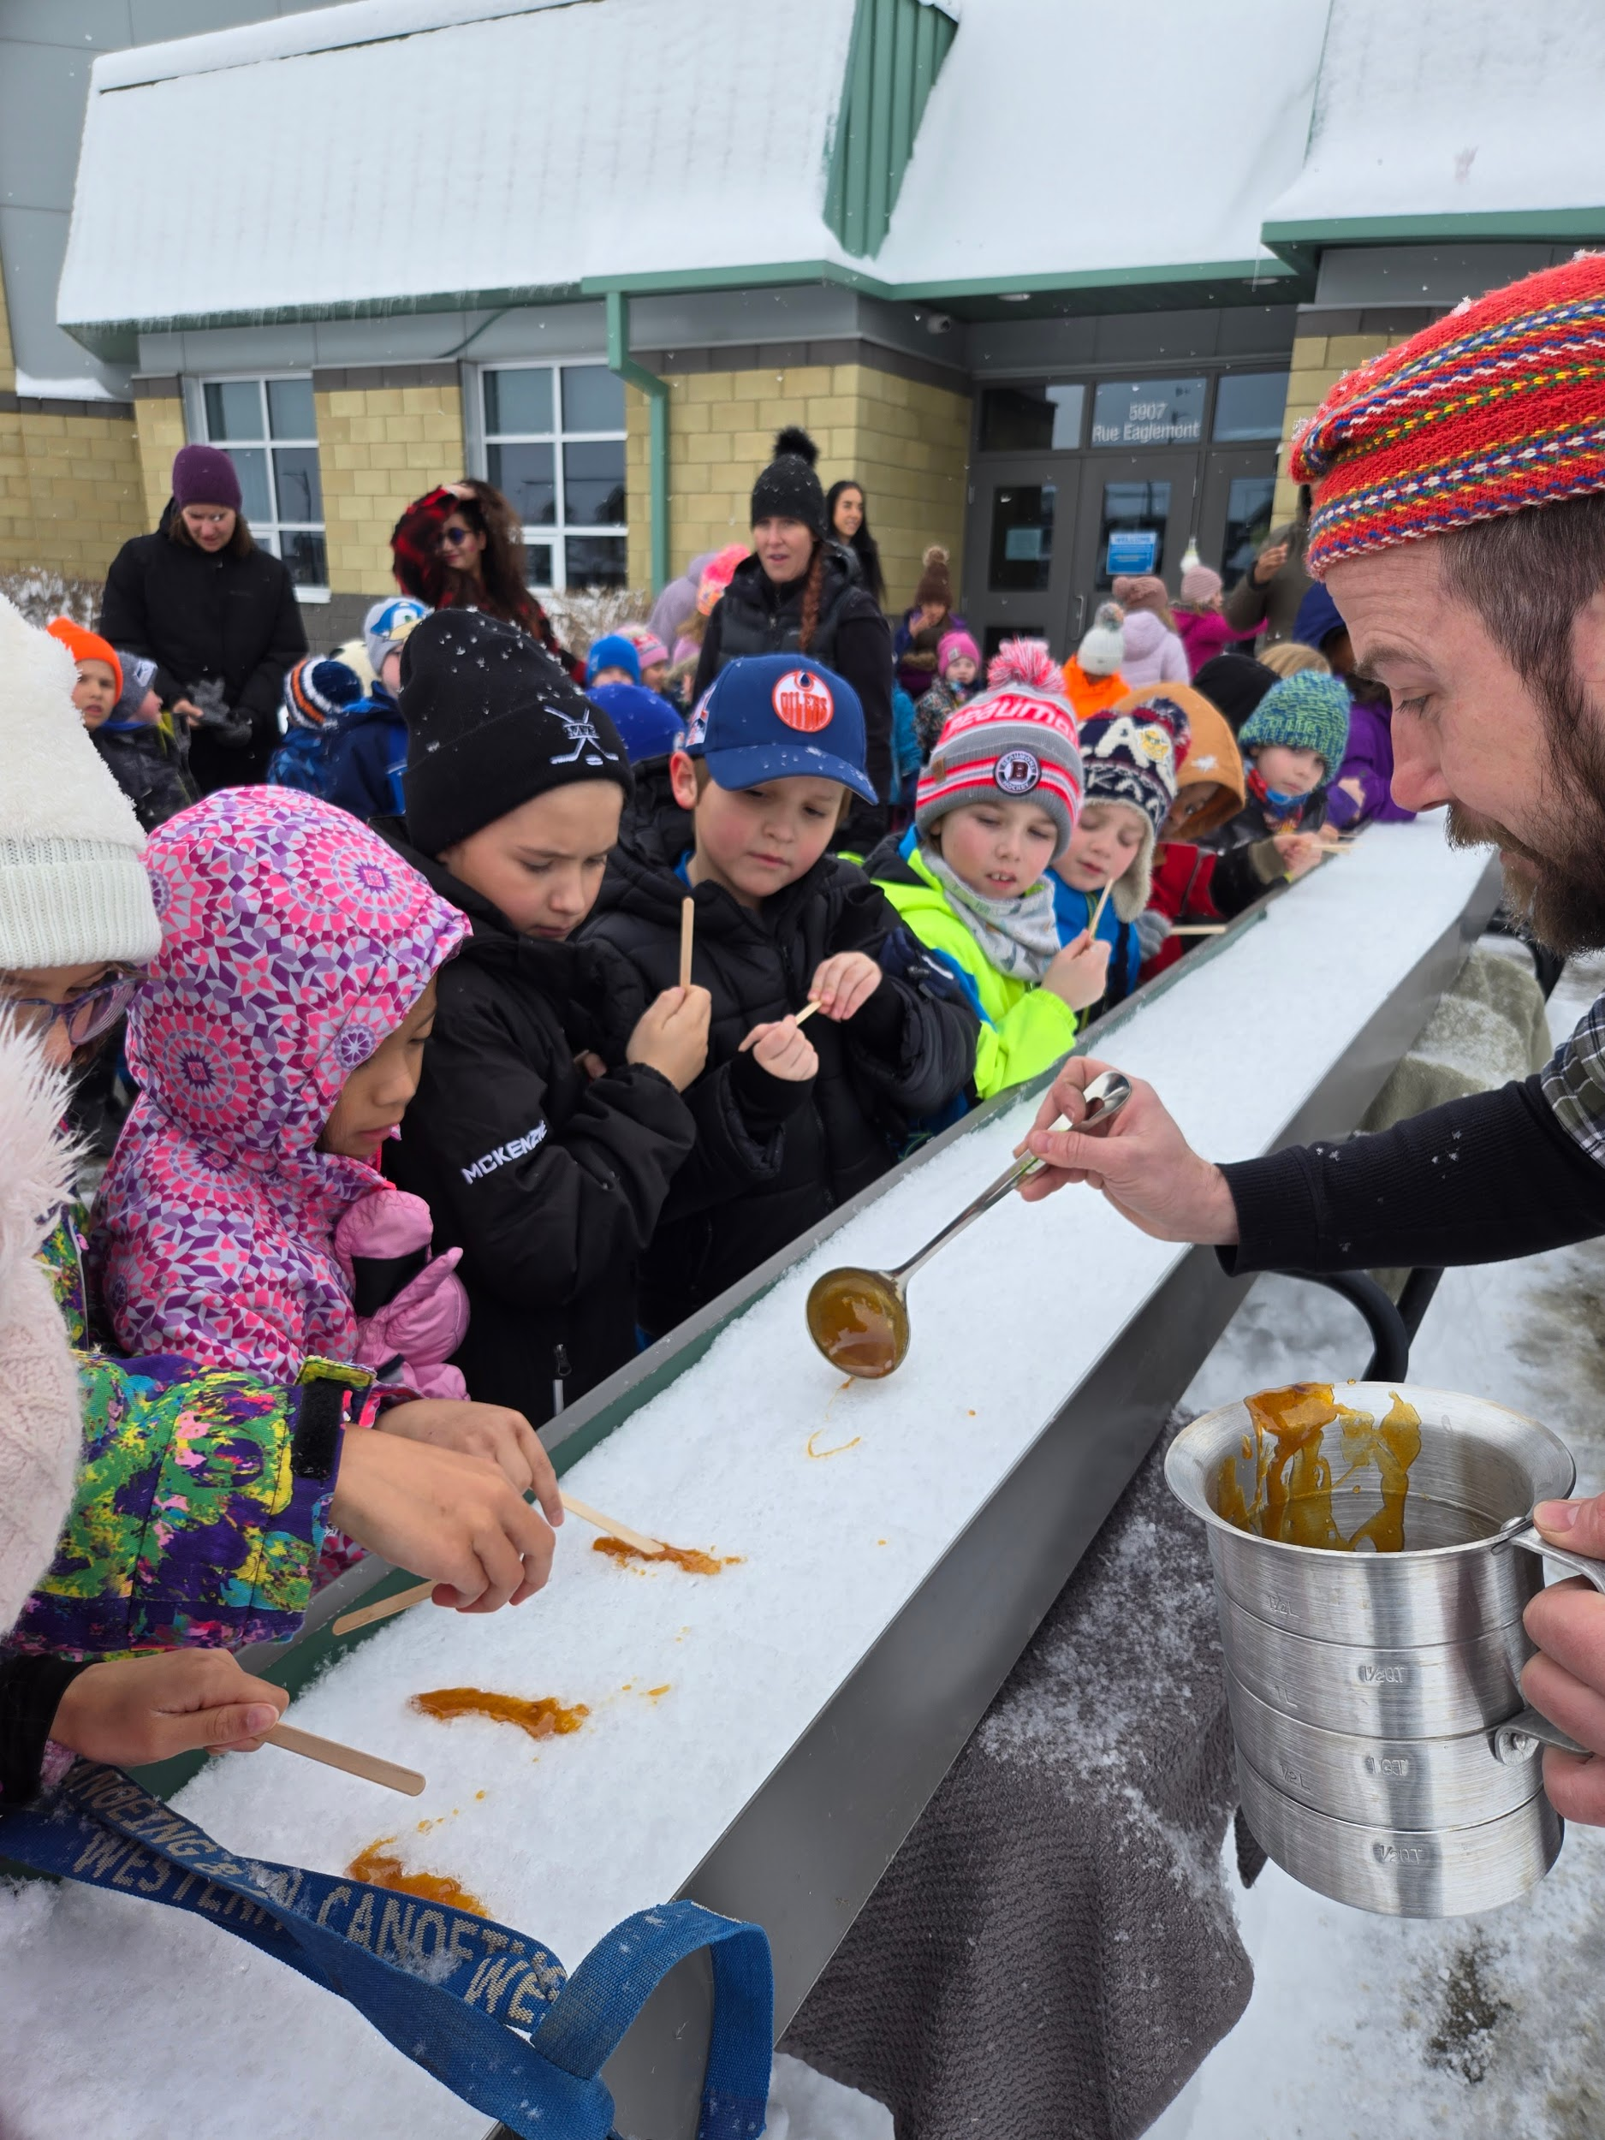
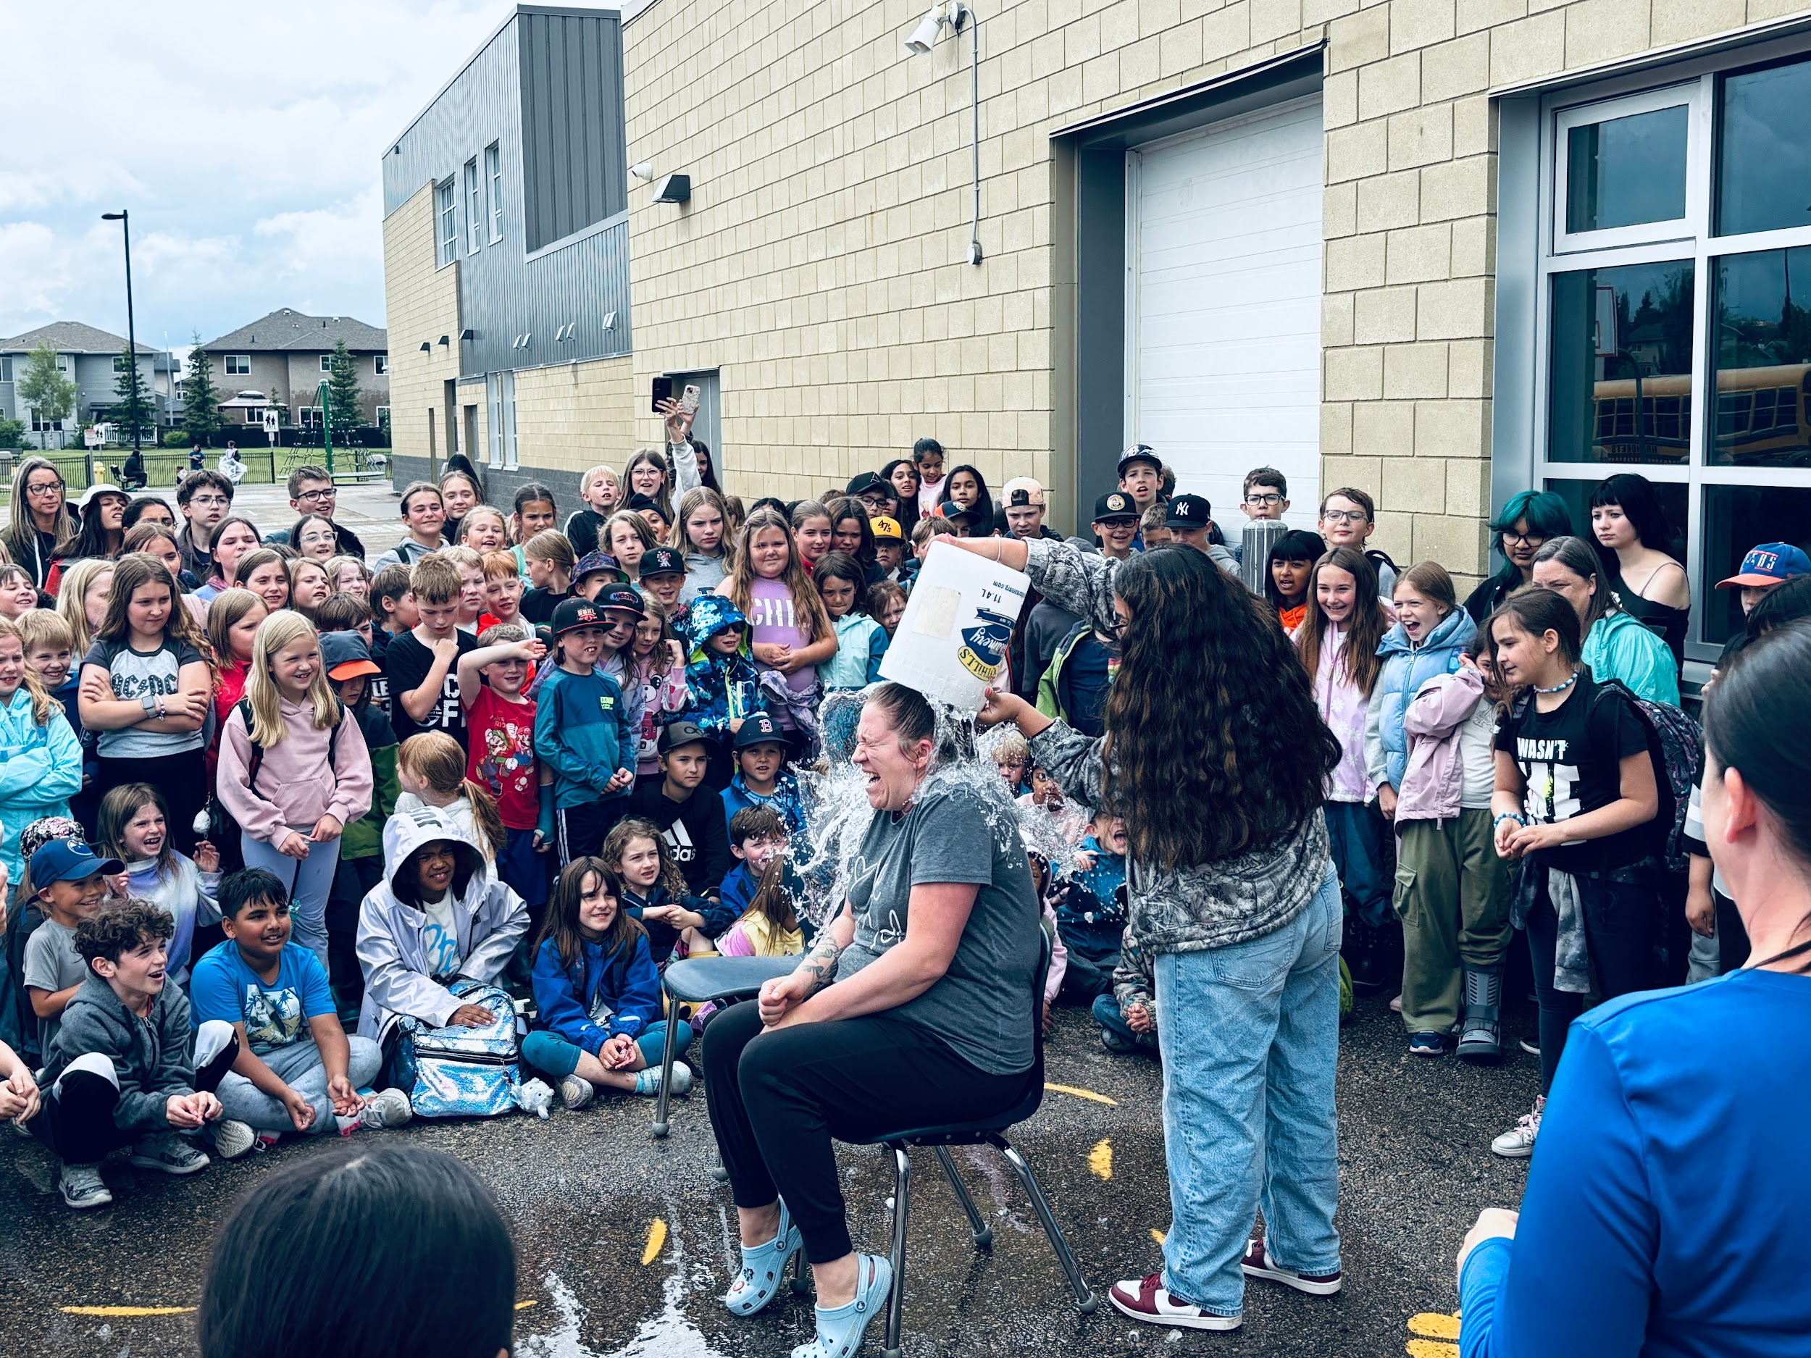

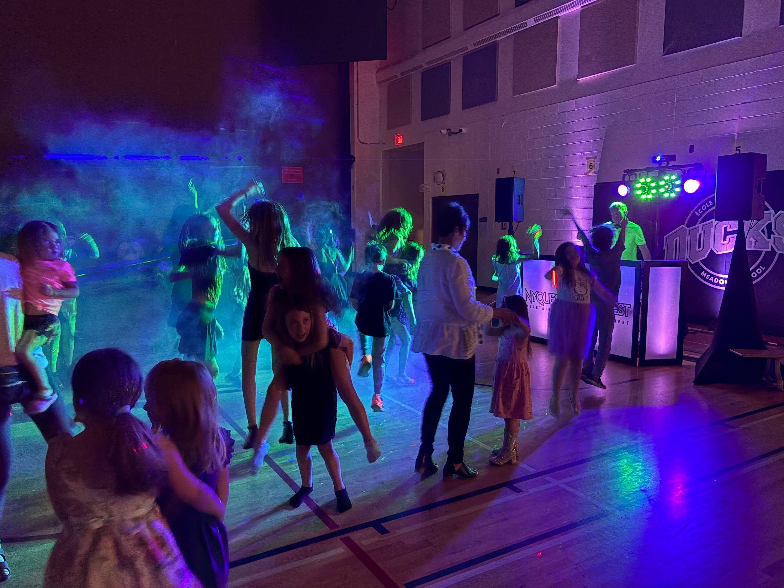

Water Bucket Challenge

Grade 9 Calgary Zoo Trip Cross Country Fall Classic Carnaval
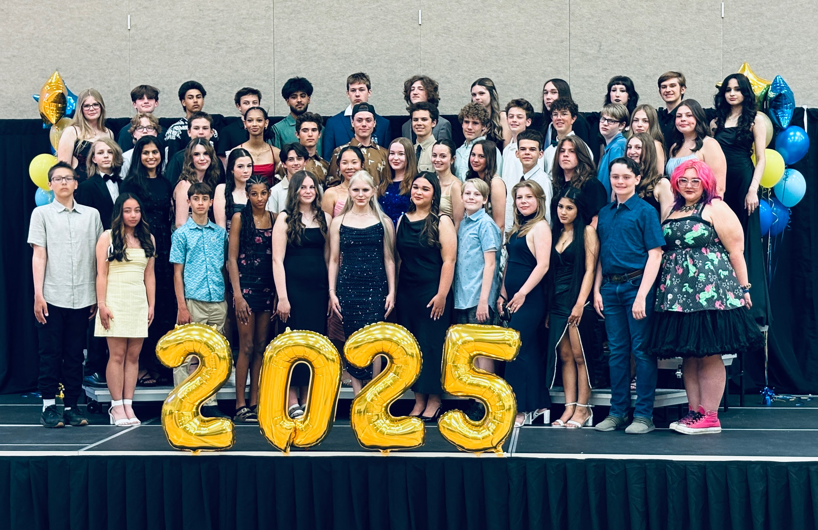
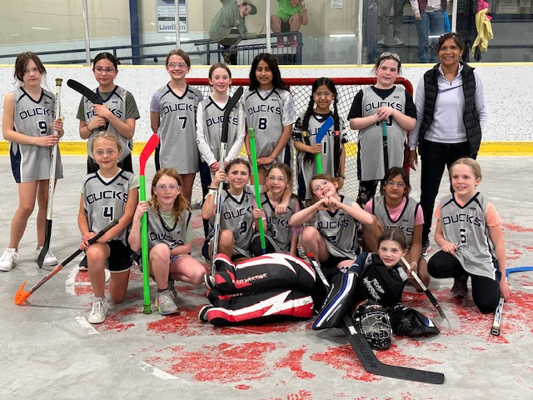

Grade 3/4 Floor Hockey - Beaumont Cup Grade 9 Farewell Spring Family Dance

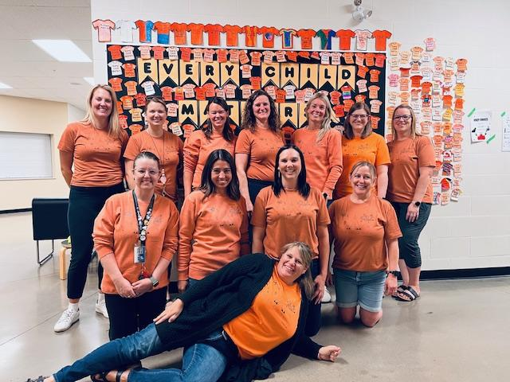
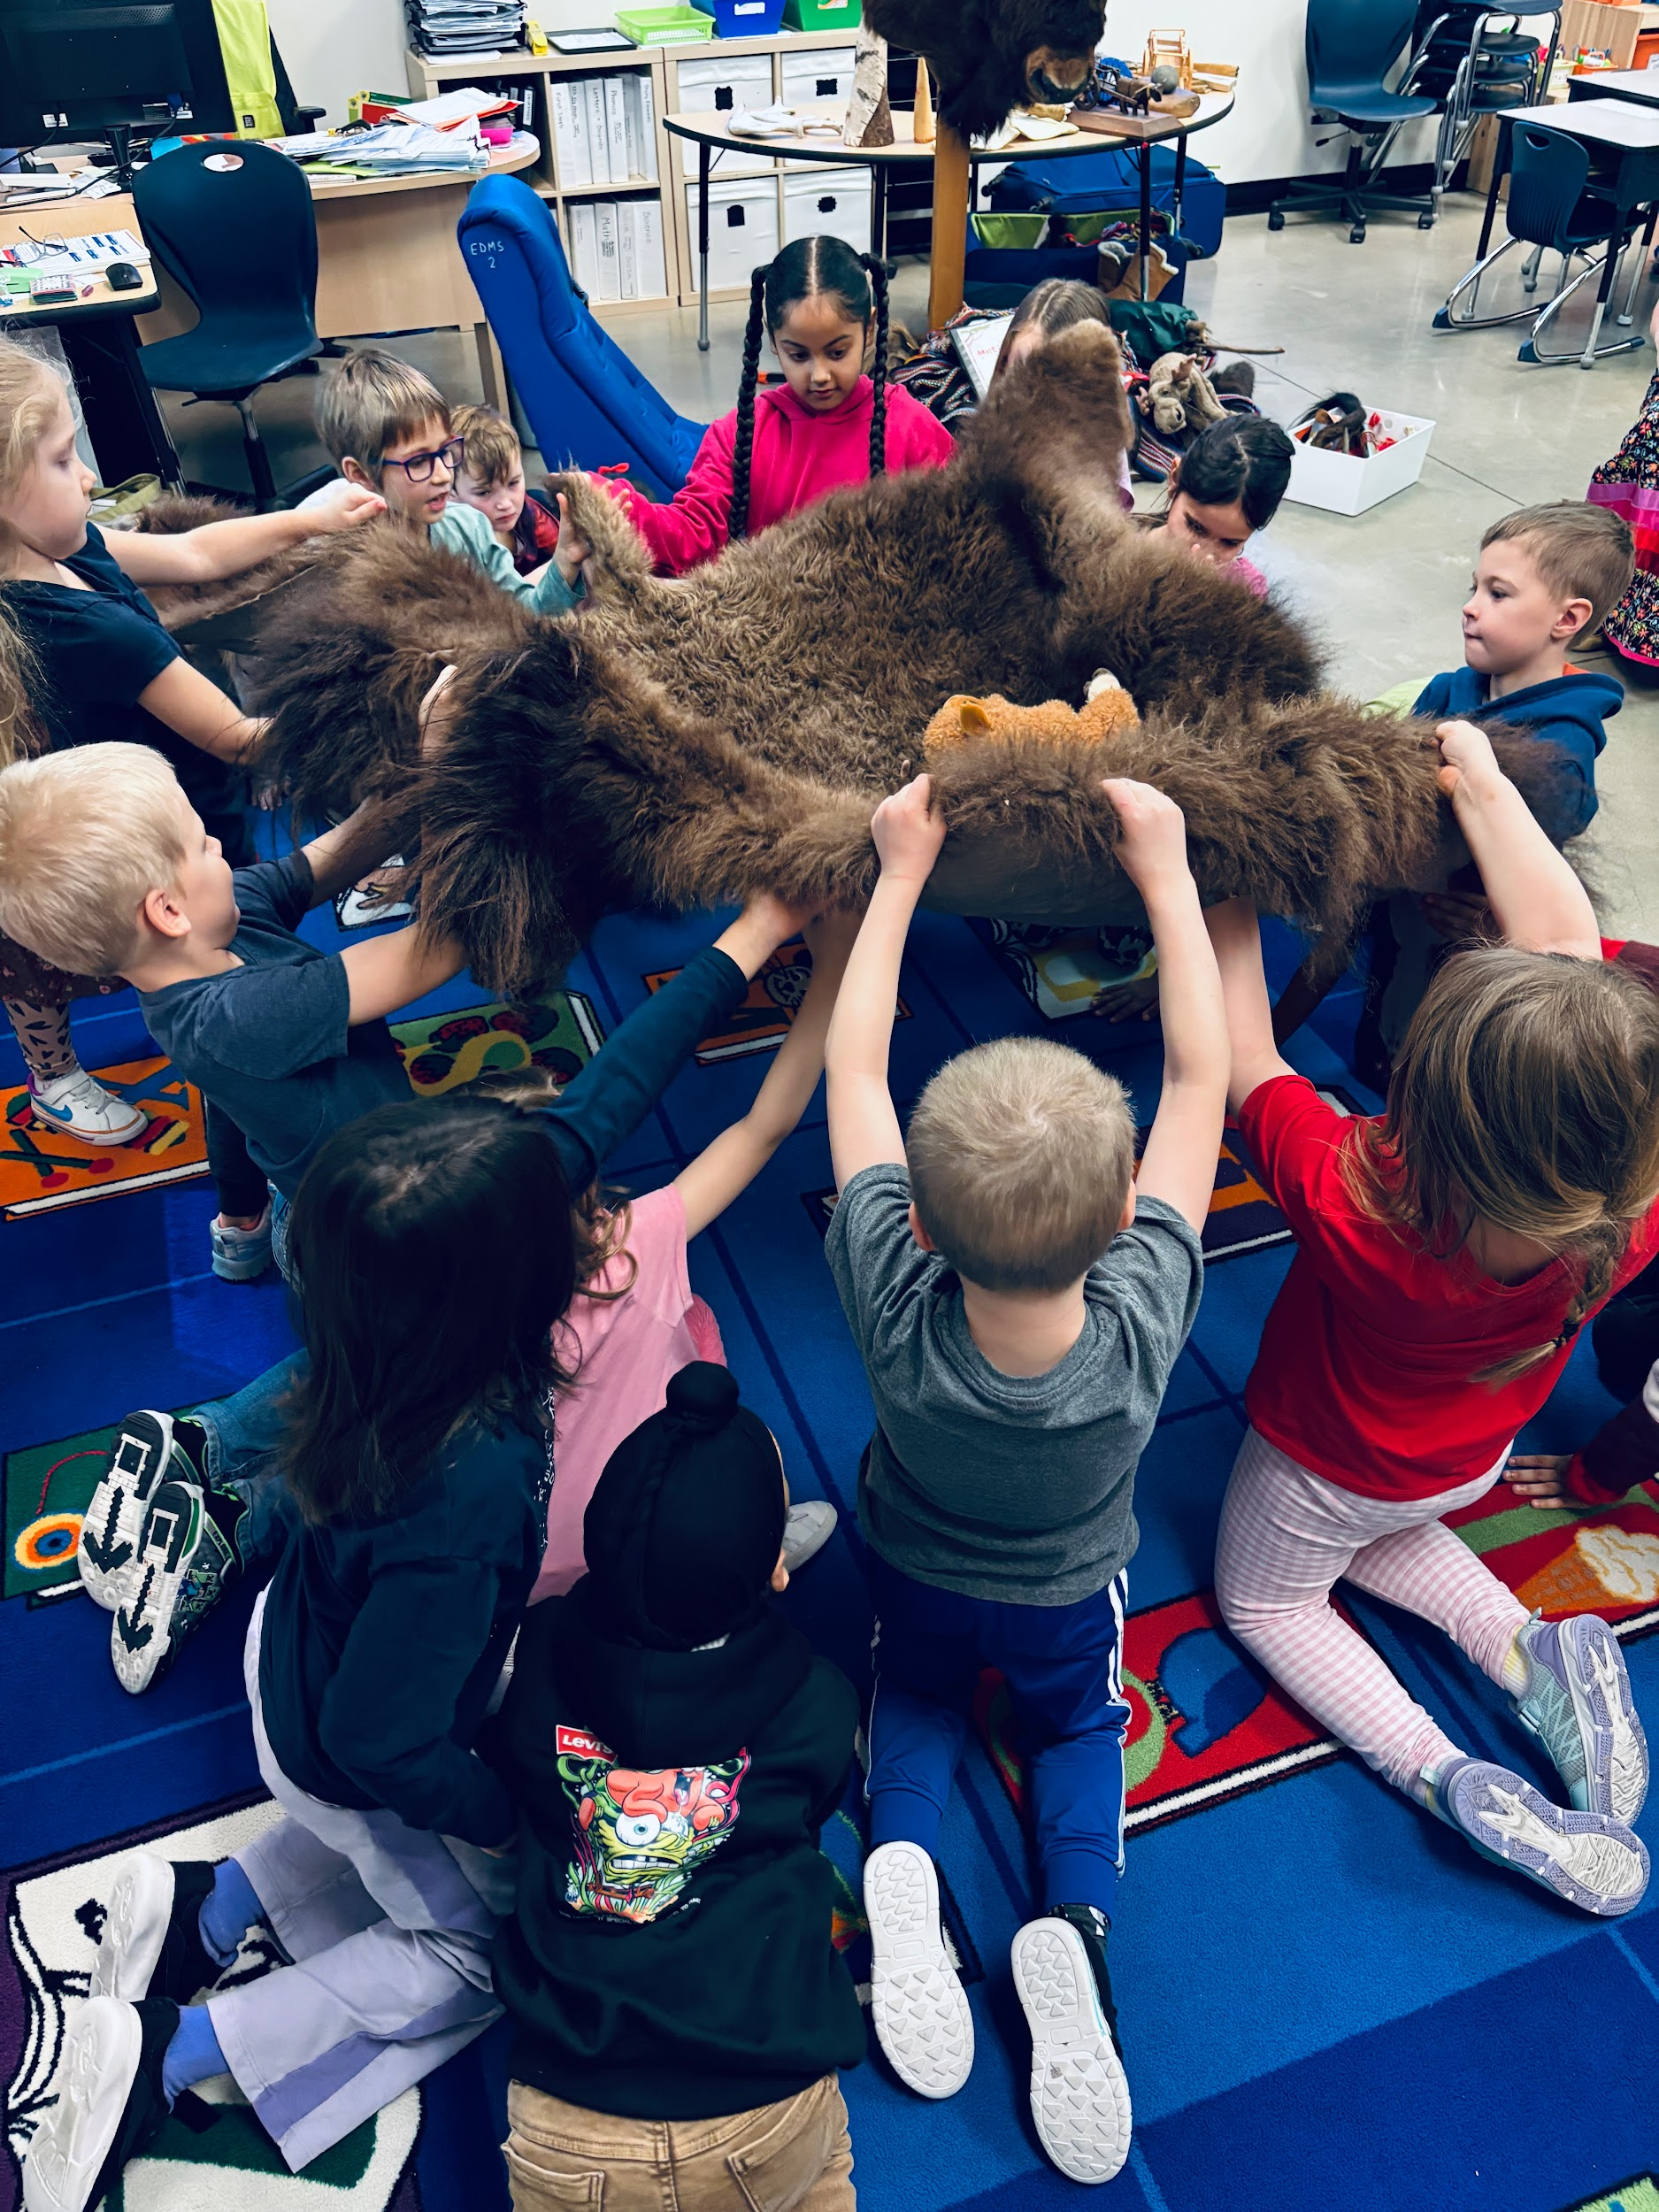
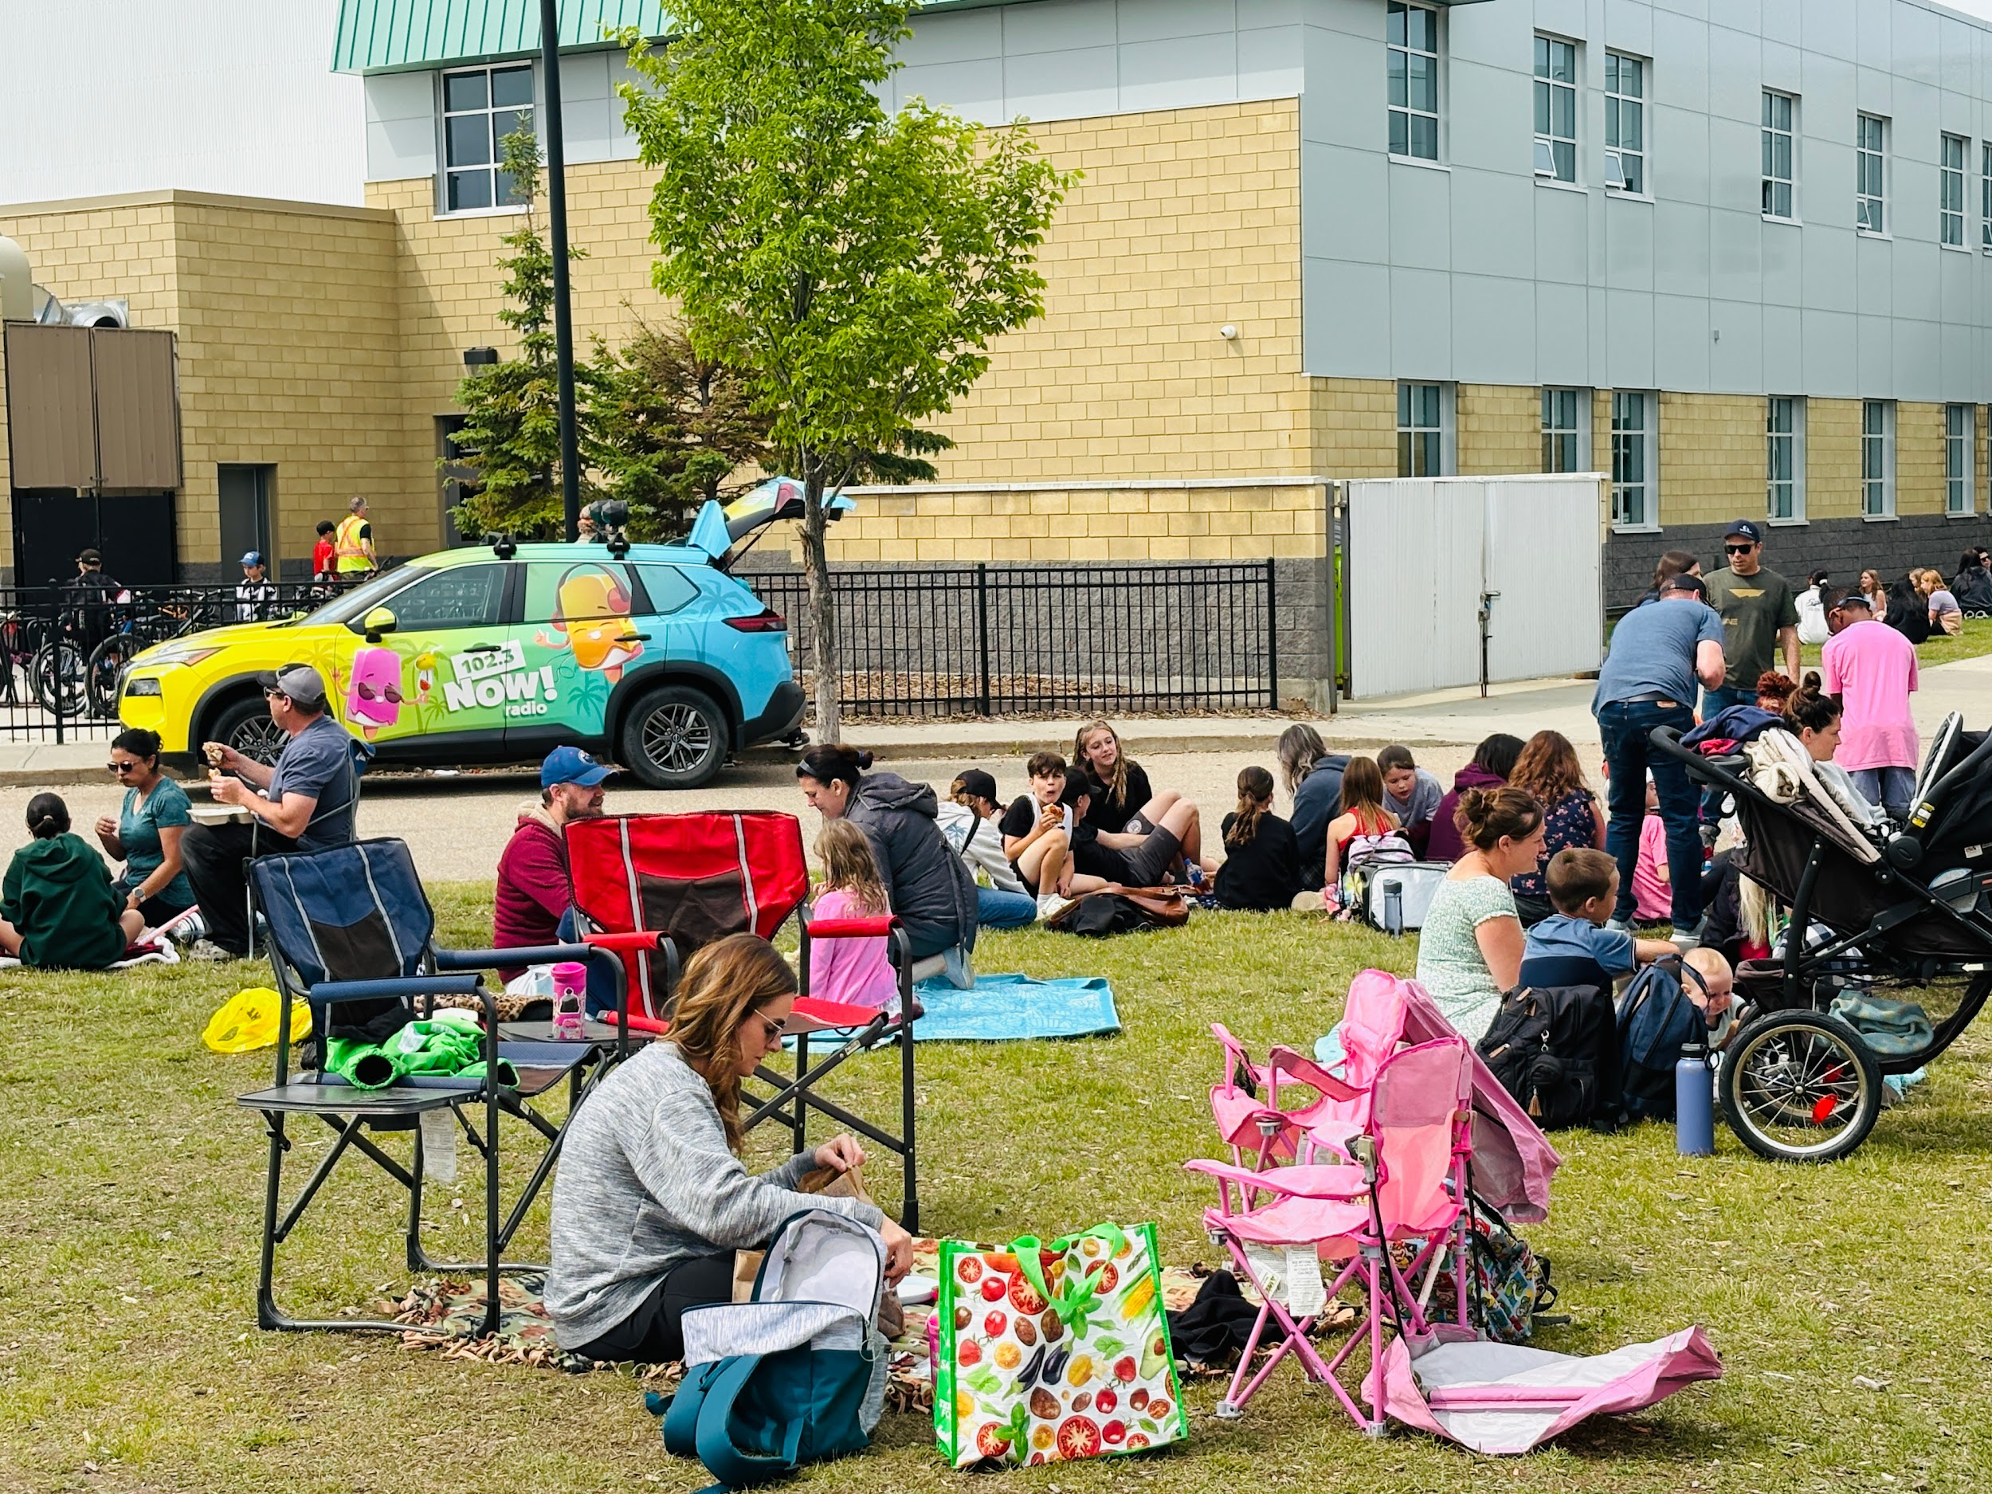
Family Picnic Felice Gladue Orange Shirts!
School Goal 1: Establishing a positive, welcoming, safe, healthy, and inclusive school culture with a focus on building resiliency and emotional well being among staff and students.

Alignment with Division Priorities (Wellness/ Success/Partnerships)

Timeline: 2025-2026
Rationale:
- Assurance results Safe and Caring Schools, Citizenship

Timeline | Strategies | Supporting Data
2025-2026 | Build teacher-student relationships & positive school culture  - Greeting and saying goodbye to students at the door (verbal and non-verbal greetings)  - Use Class morning meetings (announcements and group sharing activity, emotional check-in)  - School Spirit Days  - Create Staff Committee to support 4 Directions Teachings implementation across grade levels  - Reading Buddies  Develop empathy  - Modeling by staff  - Use literature to help students relate to and empathize with characters in books/stories.  Promote self-management skills for students  - Weekly Admin, LST, FSL, Student Services and School Counsellor Meeting  - use effective routines, structures, and procedures to reduce stress  - Promote agenda use or homework slide  - Include brain/movement breaks throughout the day  - Goal setting - students set one academic goal for the year  - promote positive mindset - Slumberkins: Educational Emotional Learning (FSL)  - Apply for PC Grant - Feeding Hungry Minds  Visible Learning PD Opportunities for Teachers | Assurance results - Safe & Caring School, Citizenship, LifeLong Learning  Data Collection -  - Understand the needs in the building  - Wrap around supports  - Communicate with staff  - Students using language and lessons to help navigate various daily emotions  Nutrition Program - provide breakfast, snacks and lunches for any student who needs them.  Data Collection -  - Learning Intentions and Success Criteria  - Effective Feedback  - Students are able to answer “what do I need to learn well?”

School Goal 2: Support all students in literacy and numeracy. This will ensure optimum student learning and common language/understanding among teachers, students, and parents.

Alignment with Division Priorities (Success)
Timeline: 2025-2026
Rationale:
- Assurance results -Education Quality, At Risk Students

Timeline | Strategies | Supporting Data
2025-2026 | Create a class profile using the data collected from assessment screeners. Teachers use this class profile to differentiate, meet students' needs.  Teachers will focus on universal support to address learning gaps.  UFLI - Grades 1 - 3 (targeted groups) & Grades 4 & 5 (Intervention)  LST will work together with teachers to review data, determine priorities from the data and share student learning strategies. | - Assurance survey results -Student Growth & Achievement, Teaching as Leading  - MIPI, HLAT, FHLAT, 3Ts, GB+  - Classroom evidence of literacy/numeracy best practices  - ISPs
 | Implement programs/strategies from Gr K-9 that enhance specific learning skills  - Haggerty K-3  - Daily 5  - Guided Reading, Guided Writing, Math Talk  - Jolly Phonics (Kindergarten)  - Je Lis (K-2 French program)  - Literacy/Numeracy Centres  - UFLI  - Leveled Reading Groups  - CORE Phonics (Grades 2-5)  - Empowering Writers  - Decodable readers  Teach ÉDMS Staff how to do Learning Walks - (December 2025) | Learning support teacher building capacity with rotations in numeracy and literacy. Pushes into classes to support teachers/students.  Teachers will use a variety of programs and strategies to address the diverse needs of all learners in their classrooms.  Data Collection -  Learning Walks -Changing the way teachers and admin question and how it impacts the way students respond.  Visible Learning - Extra sub time in order for teachers to collaborate and observe others in the building.

School Goal 3: Build capacity in Indigenous education by deepening staff understanding, integrating Indigenous perspectives across the curriculum, and fostering respectful relationships that honour the histories, cultures, and contributions of First Nations, Métis, and Inuit peoples.

Alignment with Division Priorities: (Engagement and Partnerships)
Timeline: 2025-2026
Rationale: Deepening staff understanding of Indigenous histories, cultures, and perspectives helps us create a more inclusive and respectful school community. By weaving Indigenous ways of knowing across the curriculum, we provide all students with a richer, more accurate understanding of Canada while supporting Indigenous learners in seeing themselves reflected in their education. Fostering respectful relationships with Indigenous peoples strengthens our school culture and helps us live out our commitment to reconciliation in daily practice.

Timeline | Strategies | Supporting Data
2025-2026 | - Staff tipi assembly with Elder Dale, Elder Phillip and Michael Swampy (August 26, 2025)  - Land acknowledgement in announcements every Monday morning  - Monthly Assemblies with 4 Directions Indigenous Values (starting November 2025 - Courage)  - Visibility around the building: Orange Shirt Day, Indigenous Reading area in flex Space, Bulletin Boards with student activities related to the theme  - Staff using resources supplied by Michael Swampy, including virtual collaborative activities  - Increasing Indigenous books in the library | - tipi is a respected space, used by staff and students as an additional reading area; we will smudge it in June and September each year  - Visuals of 4 Directions Teachings throughout the building.  - Monthly Focus - 1 Teaching at a time  - Assemblies: Grades 1-5 and 6-9 reflecting monthly values

